Project Proposal

On

**Online Movies Booking System**

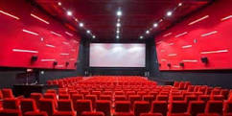

Ashish Pokhrel

00172912

Computing Project

Level 5 in Computing

Softwarica College of IT and E-Commerce

Kathmandu, Nepal

04/01/2019

Submitted to: Kiran Rana

Contents

1. INTRODUCTION 3

1.1 Justification of Project 3

1.2 Problem Statement 3

1.3 Description of Project 4

1.3.1 Features of System 4

2. Project Scope 4

2.1 Scope and Limitations 4

2.2 Aims and Objective 4

3.Development Methodology 5

3.1 Methodology used 5

3.2 Design Pattern 6

3.3 System Architecture 7

4. Work Breakdown Structure (WBS) / Scheduling 8

4.1 Work Breakdown Structure 8

4.2 Milestones 9

5. Risk Management 12

6. Configuration Management 14

7. Conclusion of the project 15

**List of figures**

Figure 1: Waterfall Model …………………………………………...5

Figure 2: Model View Controller ……………………………………………6

Figure 3: 3-Tiers Structure ………………………………………………7

Figure 4: WBS Structure ………………………………………………8

Figure 5: Days division for Tasks ………………………………………………11

Figure 6: Gantt Chart of Online Movies Booking System …………………………………………12

Figure 7: MBS on GitHub …………………………………………14

Figure 8: Tree Structure of MBS …………………………………………15

# 1. INTRODUCTION

**Project Introduction**

Nowadays, people are very modern and technology based. They want easy and stress less life. They do not want to stand on long queue. They used technology like mobile phone, Laptop and internet for buying products, ordering food and booking seat for travel or watch movie sin theaters on online. The proposed project “Online Movies Booking System” whereby customers can book ticket for movies in online from a multiplex web app in real time.

## 1.1 Justification of Project

**Background of Project**

Online Movie booking system is web portal where you can book movies for specific date or choose timing for movies show, watch movies trailer and read reviews. You can also view Upcoming movies.

You can also know the rate for Movies and timing just browsing for anywhere and anytime on online. You just need to register in the app and login to browse to all movies which are currently running in theaters and many more facilities. Customers can book 24 hours a day from anywhere for the around globe.

Online movies booking system is very user-friendly application where you can interact with system easily. You do not need to go for theater for booking for movies. You can track everything about movies, timing of movies just clicking it of web app on online. I have used PHP for programming and My SQL for manage database of movies.

## 1.2 Problem Statement

Many problems encounters during booking for movies at booking counter of respective at theaters where like one you should stand for queues for long time. The current system for movie booking is outdated and difficult to used. You should go for theaters for booking and can’t get ticket or can’t book seats which you feel comfortable during watching movies and you should go for theaters for know which movies is running and timing of movies.

The proposed system will overcome all this problem. This system enables you to know movies running in theaters, timing of movies, Price of movie, Upcoming movies, etc. facilities. Proposed system makes easing in movies booking in theaters.

## 1.3 Description of Project

### 1.3.1 Features of System

The features of proposed system are:

* **User can Register and Login to the system.**

User can register to system from registration form and login through login from which check valid username and password in database.

* **User can book movies from home.**

User can book the movies on online and also check status of availability of seats.

* **User can rate movie.**

User can rate movies after watching in theaters.

* **User can watch trailer, reviews, etc. in movies.**

User can watch trailer of movies on system and also give reviews to movies.

* **Admin can add movies.**

Admin can add, can makes changes to the system.

* **User can see lists of Upcoming Movies with trailer.**

User can see lists of upcoming movies and also watch trailer of upcoming movies.

# 2. Project Scope

## 2.1 Scope and Limitations

**Scope**

Online movies booking system is for theaters which help for storing database with information like movies date, price, upcoming movies, rating and reviews of movies and retrieve by user easily.

**Limitations**

Following are limitations of system as follows:

Payment System is not available in this system. User should pay in theaters

## 2.2 Aims and Objective

The main aim of project is to book seat for movies in the theaters from online by browsing website from anywhere anytime. Other this project is to reduce numbers of staffs in ticket counter and promote movies on the internet. To maintain custom satisfaction and to promote movies in internet. System will provide complete details of movies to the customers.

The main objectives of online movies system are to manages all movies, customer, ticket, Audi, Show time etc. It manages all information related to movies, customer, Audi, price, timing, etc. Its main objective of building this application is to reduce manual work and customer can easily book seats from their home. System will increase profit for organization. Other objective of system is to obtain statics information from booking system. To provide anytime anywhere services to the customers.

# 3.Development Methodology

## 3.1 Methodology used

I have used waterfall approach for this project. Waterfall model is first approach used in the software development. This model is sequential approach where one step must finish before start another step. In waterfall model each step is divided. Outcomes of one step is input for next step in waterfall model. Here steps are divided into six different phases i.e. Requirement analysis, Design, Implementation, testing, Deployment (TutorialPoint, 2018)

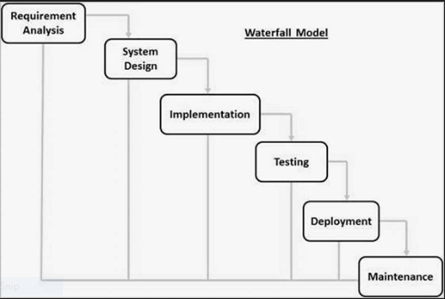

Figure : Waterfall Model

Firstly, all possible requirements are collected and document in requirement gathering phrase. From references of requirement phrase, System design is prepared. From design phrase, system is developed in small program called as unit in implementation. Each unit is tested in testing phrase which is called as unit testing. After completion of all functional and non-functional testing, system is deployed in client environment in deployment phase. After installing to client environment, system maintenance is done.

## 3.2 Design Pattern

Design Pattern is reusable solution for commonly occurring problem in software development. I am using **MVC (Model View Controller)** design pattern in this project. MVC is Model View Controller which is most used framework in software development in todays markets. It used on both desktop and web-based application.

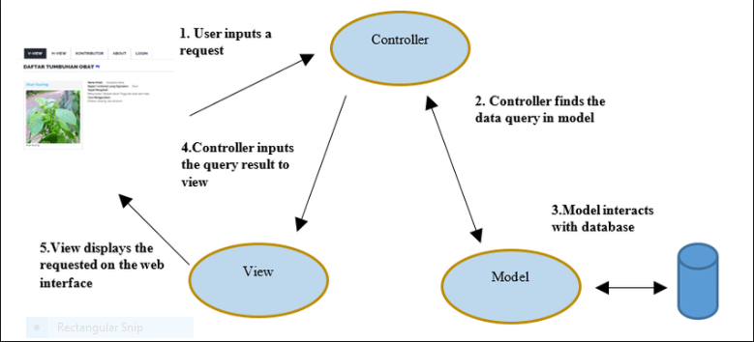

Figure : Model View Controller

**Model**

The model handles all the data related logic that user work with. This represent data that is transfer between view and controller.

**View**

The view handles all UI logic of application.

**Controller**

Controller acts as intermediary between model and view to process incoming requests and logic.

## 3.3 System Architecture

System architecture is conceptual model that defines the structure, behavior and view of system. It describes the representation of whole system. For this project, I have use 3-tier structure. (Mitre, 2016)

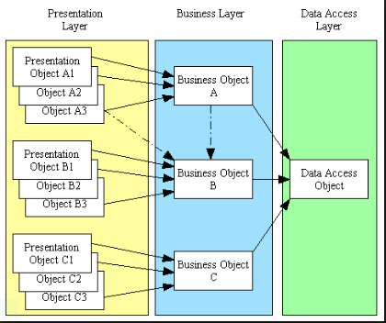

Figure 3: 3-Tiers Structure

# 4. Work Breakdown Structure (WBS) / Scheduling

## 4.1 Work Breakdown Structure

Work Breakdown Structure is process of dividing complex project into small and manageable tasks. Usually, project Manager use WBS for a project execution.

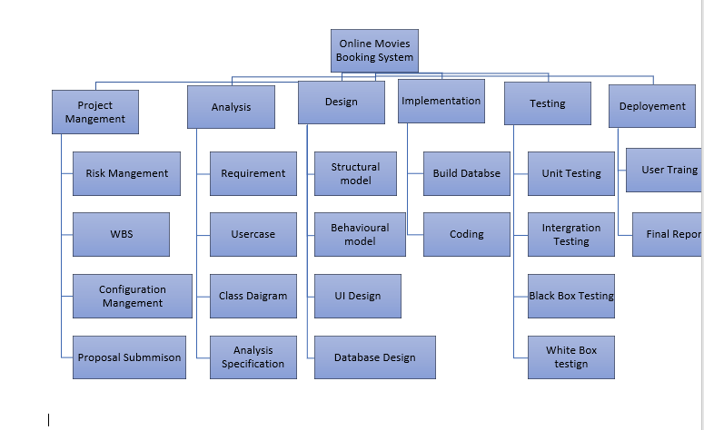

Figure 4: WBS Structure

## 4.2 Milestones

|  |  |
| --- | --- |
| **Milestones** | **Date** |
| **Project Management**  Risk Management  WBS  Configuration Management  Proposal Submission | 2018-12-21 to 2019-01-09  2018-12-21 to 2018-12-24  2018-12-25 to 2018-12-26  2018-12-27 to 2018-12-31  2019-01-01 to 2019-01-03 |
| **Analysis**  Requirement analysis  Use Case  Architecture (Initial Class Diagram)  Analysis Specification | 2019-01-04 to 2019-01-13  2019-01-14 to 2019-01-16  2019-01-17 to 2019-01-23  2019-01-24 to 2019-01-28 |
| **Design**  Structural Diagram  Behavioral Diagram  UI Design  Database Design (ER , Data Dictionary) | 2019-01-29 to 2019-02-02  2019-02-03 to 2019-02-07  2019-02-08 to 2019-02-17  2019-02-18 to 2019-02-27 |
| **Implementation**  Building Database  Coding | 2019-02-28 to 2019-03-06  2019-03-07 to 2019-03-31 |
| **Testing**  Unit Testing  Integration Testing  Blackbox Testing  Whitebox Testing | 2019-04-01 to 2019-04-03  2019-04-04 to 2019-04-06  2019-04-07 to 2019-04-08  2019-04-09 to 2019-04-10 |
| **Deployment**  User Training  Final Report | 2019-04-11 to 2019-04-15  2019-04-16 to 2019-04-20 |

**Description of Milestones**

**Project Management:**

I allocate total 14 days for this task i.e. is 4 days for Risk Management, 2days for WBS, 5 days for configuration management and 3 days for proposal.

**Analysis**

I allocate total 25 days for this task i.e. 10 days for requirement analysis, 3 days for Use case diagram, 7 days for Class Diagram, 5 days for Analysis Specification.

**Design**

I allocate total 30 days for this task i.e. 5 days for Structural model, 5 days for Behavioral model, 10 days for UI design, 10 days for database design.

**Implementation**

I allocate total 32 days for this task i.e. 7 days for database build and 25 days for coding.

**Testing**

I allocate total 10 days for this task i.e. 3 days for unit testing 3 days for integration testing, 2 days for black box testing and 2 days for white box testing.

**Deployment**

I allocate total 10 days for this task i.e. 5 days for user training and 5 days for Final Report.

**4.3 Scheduling / Gantt Chart**

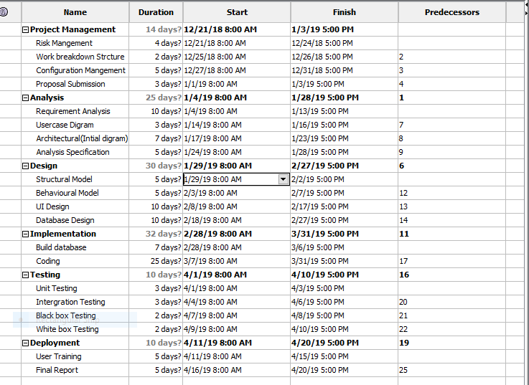 Figure : Days division for Tasks

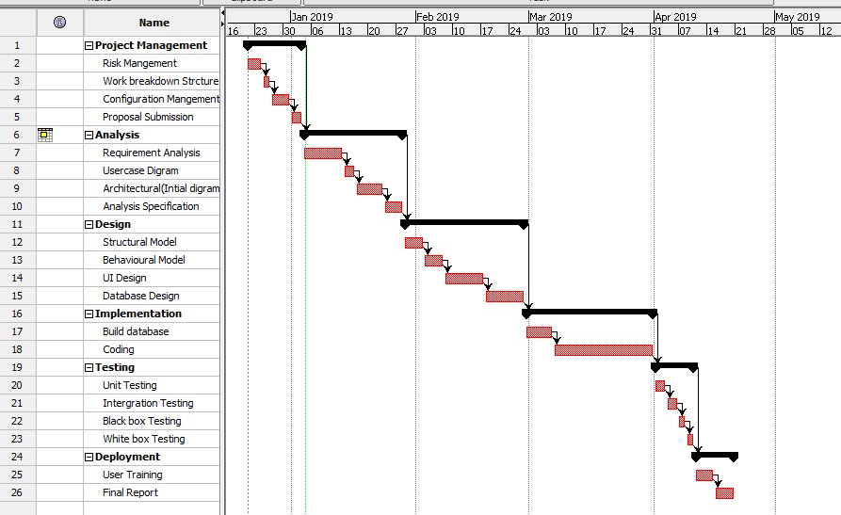

Figure 6: Gantt Chart of Online Movies Booking System

# 5. Risk Management

Risk Management is the process of identify, analyzing of risk factor in project. It should be part of planning process to figure out risk in the project and control risk for future events.

Following are the method to control risk in Project Management: (Watt, 2018)

Avoidance:

Reduction:

Sharing:

Retention:

**Impact = Likelihood * Consequence**

Risk Likelihood values are shown as follows

|  |  |
| --- | --- |
| Likelihood | Value |
| Low | 1 |
| Medium | 2 |
| High | 3 |

Risk Consequence values are shown below

|  |  |
| --- | --- |
| Consequence | Value |
| Very low | 1 |
| Low | 2 |
| Medium | 3 |
| High | 4 |
| Very High | 5 |

Risk Consequence values are shown below

|  |  |  |  |  |  |
| --- | --- | --- | --- | --- | --- |
| S. No | Risks | Likelihood | Consequences | Impact | Solution |
| 1 | Insufficient resources | 2 | 3 | 6 | All required resources for the project should be collected. |
| 2 | Hard Disk Failure | 1 | 5 | 5 | Data must back up. |
| 3 | Requirement does not meet | 2 | 5 | 10 | Proper planning should be done. |
| 4 | Server Failure | 1 | 4 | 4 | Online Backup should be done. |
| 5 | Lack of skill | 1 | 3 | 3 | Training should provide for skills employees. |
| 6 | Scheduling problem | 2 | 4 | 8 | Divide tasks in different schedule |
| 7 | Lack of cost | 2 | 4 | 8 | Cost estimation should be done properly. |

# 6. Configuration Management

The term refers to the system which track hardware, software and related information of the system. Configuration management is involving practices of processing system changes systematically with updating system while maintain the system integrity. To achieve of goal of the system, configuration management should be implemented with details polices, procedures to manage to version. Version controls are the category of software tools that helps to manage source code for the software team. (Atlassion, 2018) 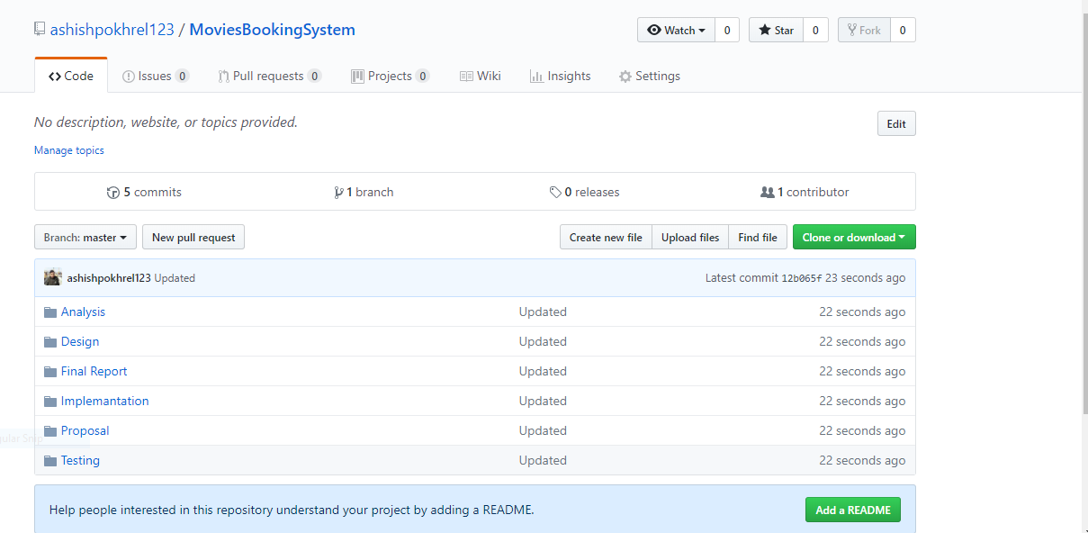

7: MBS on GitHub

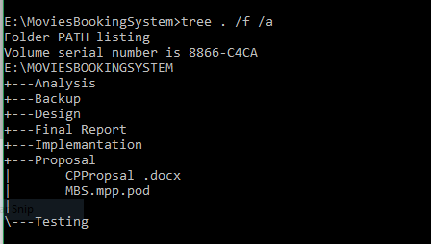

Figure 8: Tree Structure of MBS

# 7. Conclusion of the project

Online Movies Booking system is a customized and user friendly a web application where you can book seat for movies in theaters from anywhere anytime. It has facilities of booking movies, read reviews of movies, watch trailer, see lists of upcoming movies. Admin can add lists of movies. Suitable breakdown and scheduling are done properly. Design pattern MVC and waterfall methodology is used for the project. The only one limitation of the system is online payment system is not available.

# References

Atlassion. (2018). Retrieved from https://www.atlassian.com/git/tutorials/what-is-version-control

Mitre. (2016). Retrieved from https://www.mitre.org/publications/systems-engineering-guide/se-lifecycle-building-blocks/system-architecture

TutorialPoint. (2018). Retrieved from https://www.tutorialspoint.com/sdlc/sdlc_waterfall_model.htm

Watt, b. a. (2018). Retrieved from https://opentextbc.ca/projectmanagement/chapter/chapter-16-risk-management-planning-project-management/